

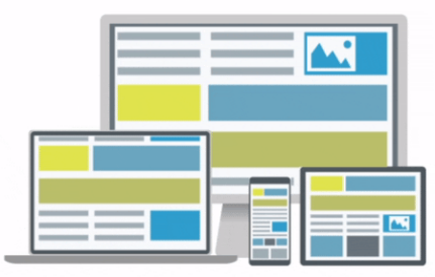

**Bootstrap 5 The Next Generation of Web Development**

**Before learning Bootstrap 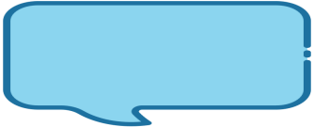**HTML 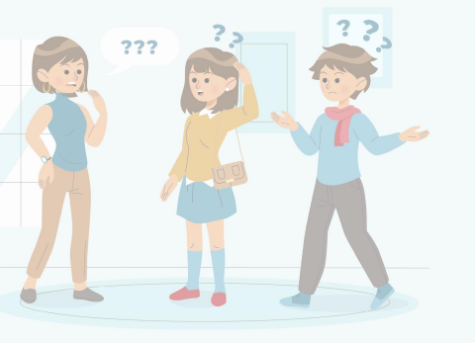

CSS

**Responsive Web Design**

Responsive web design (RWD) is an approach to 

web design that makes websites look good and

function properly on a variety of devices, from large

desktops to small smartphones.

**What is Bootstrap**

**Bootstrap is a widely-used front-end framework used to build**

**responsive user interfaces.** 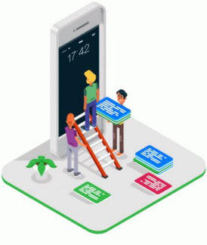

**It provides a collection of pre-built HTML, CSS and javascript**

**components and utilities.**

**Bootstrap simplifies the process of creating consistent and**

**professional-looking web interfaces by offering a wide range of ready**

**to-use UI components**



**History of Bootstrap**

Bootstrap, originally named Twitter 

Blueprint ,was developed by Mark Otto

& Jacob Thornton at Twitter.

Bootstrap was released as Open source

project on August19,2011



**Responsive Design:**

**Benefits of Bootstrap Time Efficiency:**

Bootstrap is built with a mobile-first 

approach, ensuring that websites

and web applications created with it

are responsive and adapt well to

various screen sizes.

**Consistency and Uniformity:**

Bootstrap provides a wide range of pre-built components and templates, allowing developers to quickly prototype and build web interfaces. 

By using Bootstrap, developers can ensure that 

their websites have a cohesive look and feel, with consistent typography, spacing, and color schemes.

**Cross-Browser Compatibility:** Bootstrap has been extensively tested across different web browsers, ensuring compatibility and consistent rendering across major browsers

**Customization:** 

Developers can easily modify and tailor the framework to match their project's specific requirements.





**What's New in Bootstrap 5**

**Enhanced grid system:** More 

flexible and customizable grid

layout.

**Updated default typography:** 

Improved default typography

for better readability.

**Reimagined forms:** 

Redesigned form controls and 

validation styles.

**Removed jQuery dependency:** Bootstrap 5 no longer relies on jQuery. 

**New utility classes:** Additional utility classes for spacing, sizing, and more. 



**How to Get Started with Bootstrap 5**

**Set Up Your Development Environment:** 

Make sure you have a text editor or integrated development environment (IDE)

installed on your computer. Popular choices include Visual Studio Code, Sublime Text.

**Download Bootstrap:**

Visit the official Bootstrap website at https://getbootstrap.com/.Click on the "Download" button to download the latest version of Bootstrap. 

You have two options: download the compiled CSS and JavaScript files or download the source files to customize and compile them yourself.













**Link Bootstrap in Your HTML File:**

Create a new HTML file or open an existing one in your preferred text editor. In the head section of your HTML file, include the Bootstrap CSS file

Just before the closing </body> tag, include the Bootstrap JavaScript file. Start Using Bootstrap Components: